Studio Practice Assignment 1 Review on Swords and Potions

For this assignment I have chosen the game Swords of Potions. Swords and Potions is a freemium game based in the medieval age and the player plays and as young medieval merchant who owns a shop in a kingdom. The player objective is to build up their shops reputation, size and location by employing staff members who can forge certain products so then you can sell it to buying customers. As the player continuously is successful selling products to customers then talk to other people in the kingdom, gaining the players shop awareness and after enough influence gas been gained they can move into the castle and even into the citadel to continue selling their goods.

One mechanic in the game is customer browsing. The Author thinks that when the player is in the game and a customer comes into the shop they sometimes don’t want the player’s attention. This causes confusion to why they even came in in the first place and thinks this is “somewhat of an annoyance” for the Author. This is shown in figure 1. Also it doesn’t seem like there’s any positive or negative effects when this happens ad seems to look like a waste of time (A fandom User 2013).

Xiviar disagrees with what the Author thinks about this mechanic as it’s an excellent idea because it is very realistic and in the real world not everyone comes into a shop to buy something, and if they are interrupted there is a high chance they will get annoyed and put off buying anything. So the Xiviar suggests leaving this person alone and then they may want to buy something later by showing a question mark icon above there avatar (Xiviar 2013).

Another mechanic in the game that drives revenue is the in game resources. The resources list is split into four categories of three rarer ingredients. In the first column on resources list lays metal, wood, leather and herbs. These cost the cheapest and therefore common resources and then there is steel, fabric oil and elfwood which is uncommon resourcses costing the player a little more. All of these resources cost in game currency earned whist playing the game known as gold pieces, this is shown in figure 2. The third column however has to currently exist or purchase in game tokens per each unit of recourse, Kronoan believes that this is way too expensive and it’s not worth it and the tokens can be better spent making recipes. (Kronoan 2013).

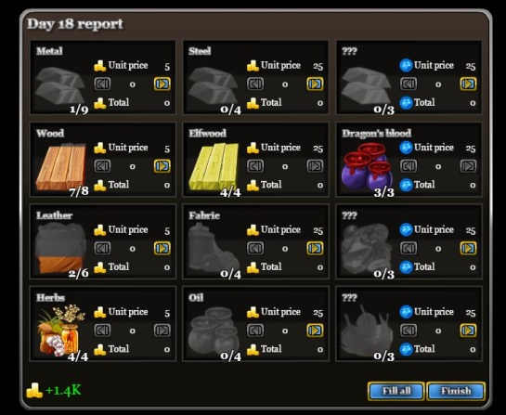

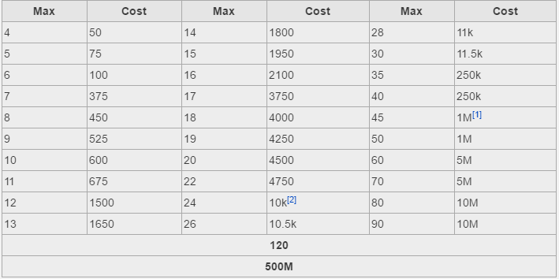Another mechanic in the game that drives revenue is the in game resources capacity load/ bins. When you first play the game each normal resource bin has a capacity of 3 and then the player can increase the space of these bins by using gold in game currency. Once the player reaches the capacity of thirty each purchase after that gives them 5 more units of space rather than one. As the player adds more capacity space to the bins the more gold pieces it will cost them to further increase the space in the bins to use as shown on figure 3. Kronoan believes that after reaching a certain amount of capacity it becomes too expensive and almost not worth purchasing and the in game gold can be used on making potions instead (Kronoan 2013).

The way the game has been marketed is by gaining permission from several online games companies and websites like Kongregate, Armour games and Edgebee and many more. This helps the game gain a lot of awareness from the players that play the game on these websites as well as lots of in game feedback from various kinds of players which can vary from profession to social. This feedback can also help the game make improvements to make the game better and more appealing towards all types of players like the 10th November 2013 update which allowed players to increase the capacity size of their recourse bins (Kronoan 2013). This is known as community building.

The customer selecting mechanic in Swords and Potions I think is a great as well as a bad idea. I agree with what Xiviar has to say about this mechanic because not everyone goes into a store/ shopping and buy anything and therefore gives an element of realism into the game. It also gives out a form of challenge for the players because if they choose the wrong customers they may annoy the one they choose as well as lose other customers due to them waiting too long and possibly gaining a bad reputation and losing more customers.

I also agree with what the Author has to say about this mechanic. I agree because it is very annoying for the player to lose customers due to this mechanic and therefore missing out in profit for the day as well as possibly getting less customers in future in game business days.

The in game resources mechanic I think are priced well for the first two columns because they clearly state the difference in value and how they differ in rarity. This is also shown when the player is crafting certain items in the game for example a toy sword only requires one unit of metal and one unit of wood as for the wizards hat which requires 3 units of fabric.

I do agree with what Kronoan has to say about the third column of resources because it’s not worth 25 tokens per each unit and there should be an option to pay with in game gold as well as tokens.

So I can conclude that Swords and Potions is an good game because it is fairly realistic compared to the real world like the customer mechanics but the in game purchases need to be a little more appealing because they charge to much for what the player is getting in return.

## References

<http://www.gamezebo.com/2012/01/25/swords-and-potions-review/> 11/11/16 13.10pm

<http://swordsandpotions.wikia.com/wiki/Cooperation_improvement_mechanics> 11/11/16 13:25pm

<http://swordsandpotions.wikia.com/wiki/Improvements> 11/11/16 13:30pm

<http://swordsandpotions.wikia.com/wiki/Browsing_customers_mechanic?action=edit&section=1> 11/11/16 13:45pm

<http://swordsandpotions.wikia.com/wiki/User_blog:JonathanHuff/Today%27s_update>

<https://taogaming.wordpress.com/2011/09/03/swords-and-potions-thoughts-of-real-games/>

<http://swordsandpotions.wikia.com/wiki/Resources>

<http://www.tru.ca/__shared/assets/Critical_Analysis_Template30565.pdf>